# Step 1: Install and Set Up Foundry

## Install Foundry

Foundry is a next-generation Ethereum development framework. Install it using the following command:

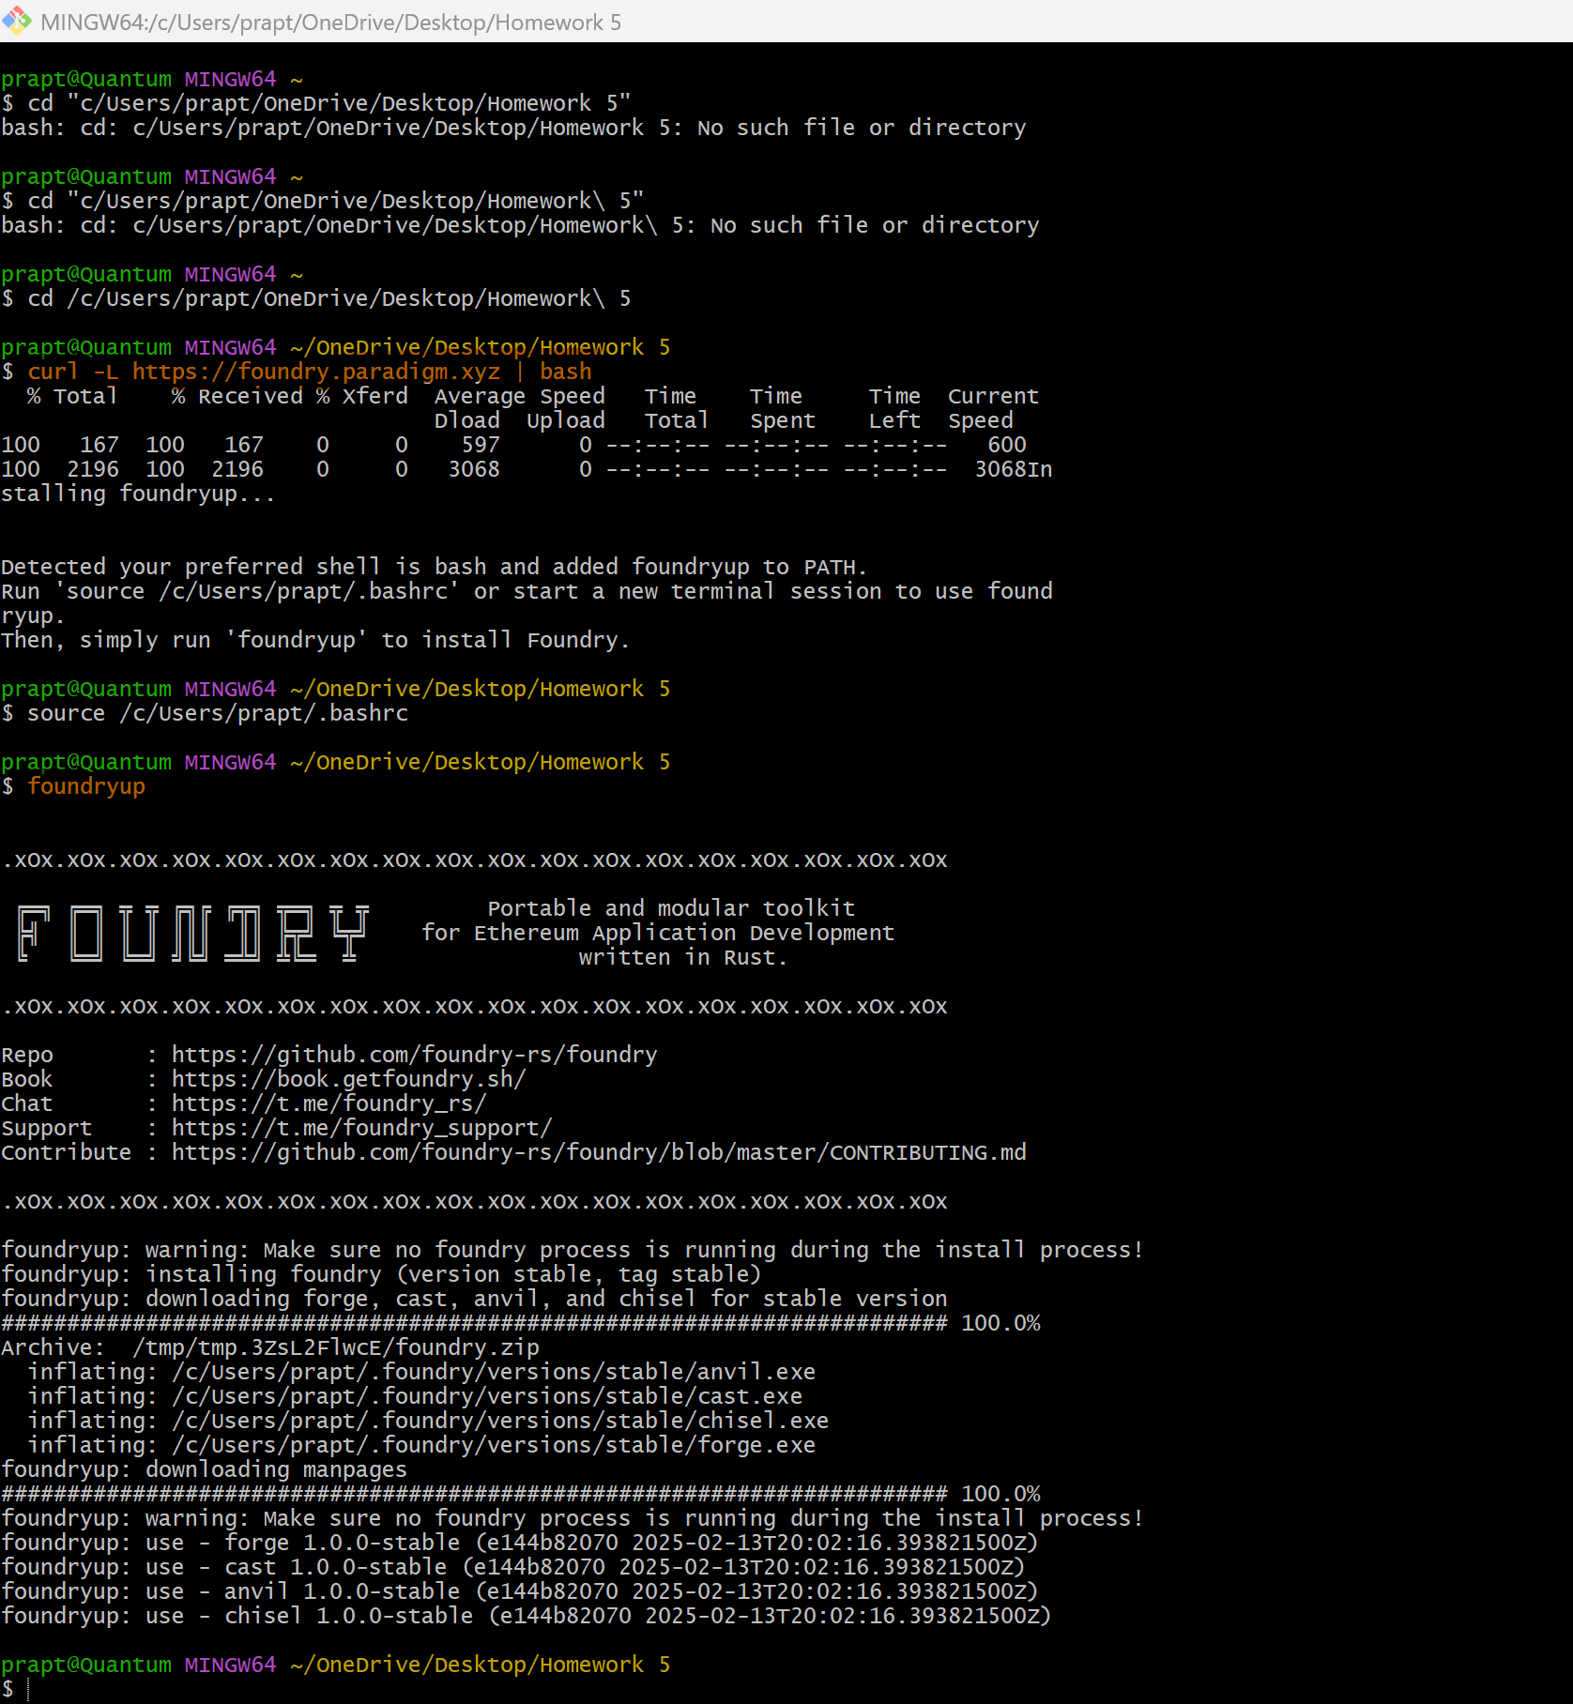

To verify installation, run:

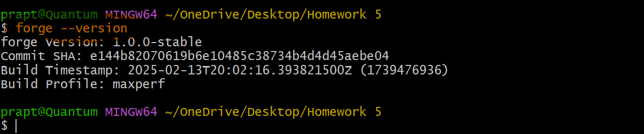

# Step 2: Initialize the Foundry Project

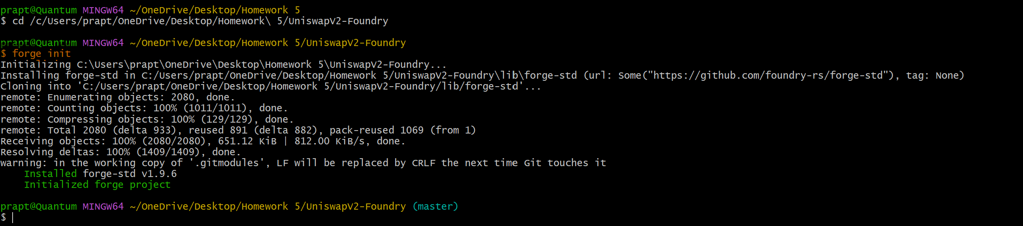

# Step 3: Clone & Organize Uniswap V2 Code

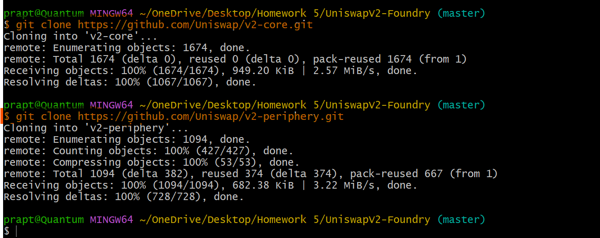

# Step 4: Install Dependencies and Verify

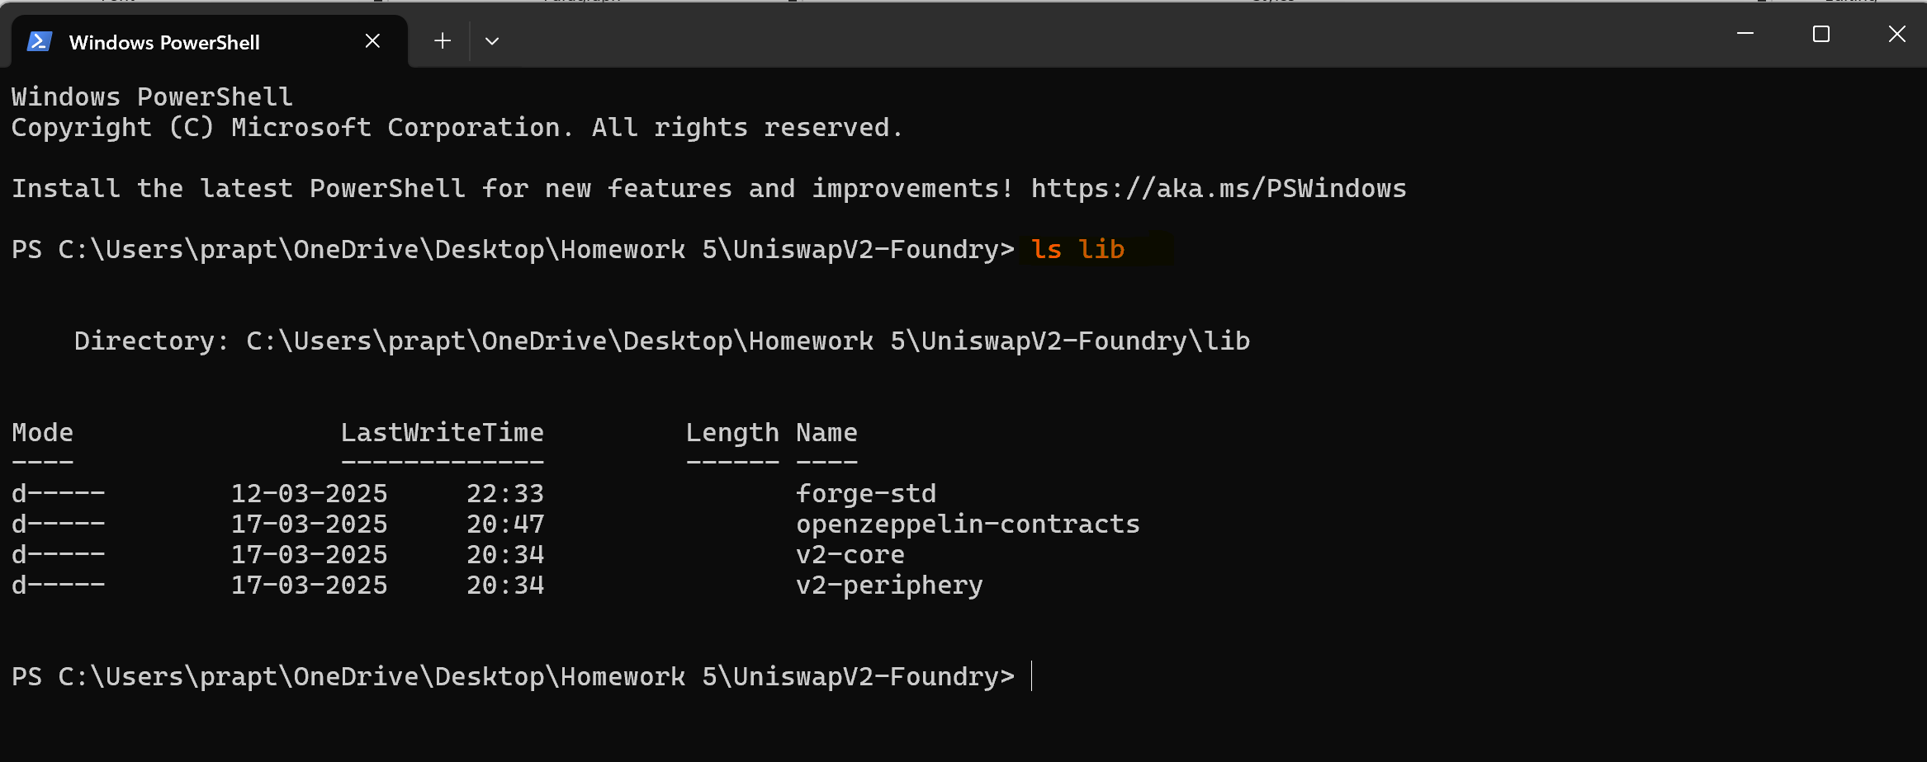

# Step 5: Set Up Import Remappings

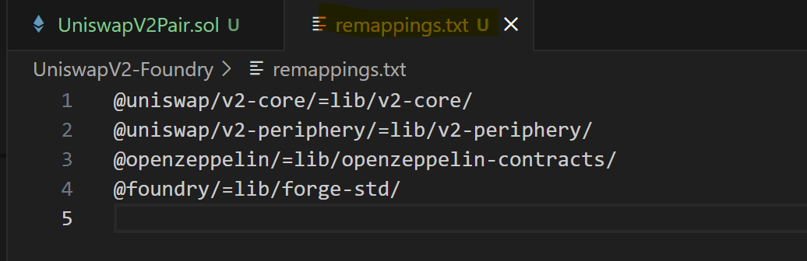

## Verify Remappings.txt

